**Java collection**

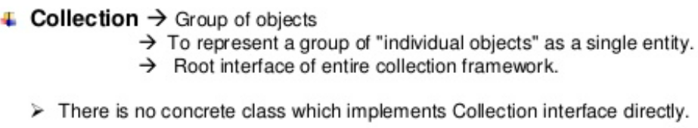

**1)It is an interface and extends Iterable Interface. It represents single unit of objects, i.e group-------------------------------------**

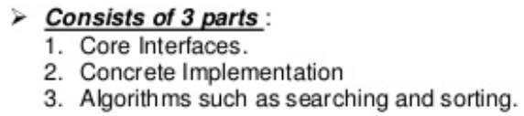**2) Collection Framework-it represents a unified architecture for storing and manipulating group of objects. It**

has -1) interfaces and its implementations. i.e classes and 2) Algorithms.

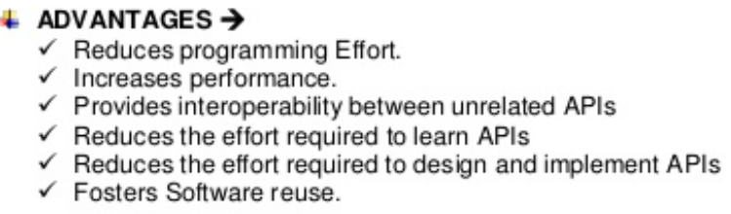`1) due to ready to use code

2) because of high performance implementations of data structures and algorithms. And 3) it is easy to learn.

3) helps to reuse the code



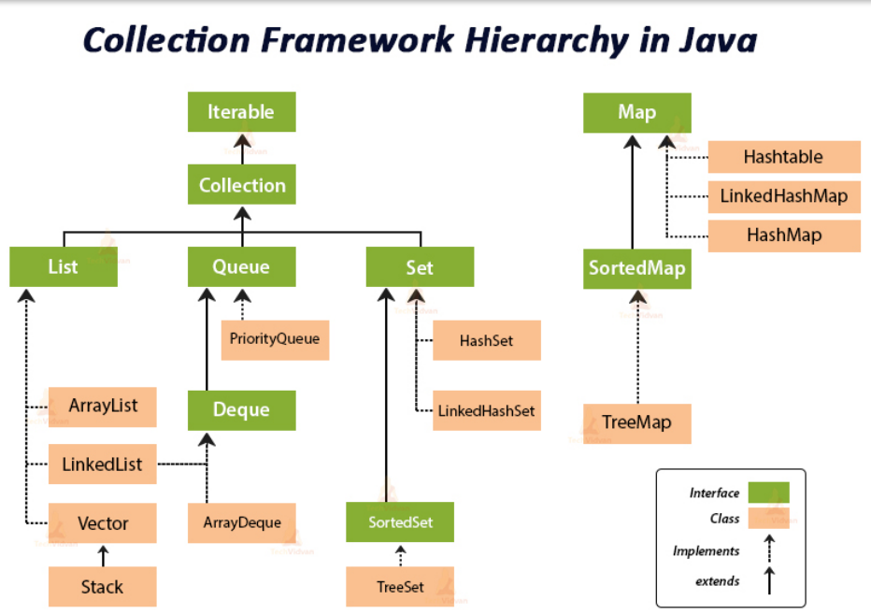

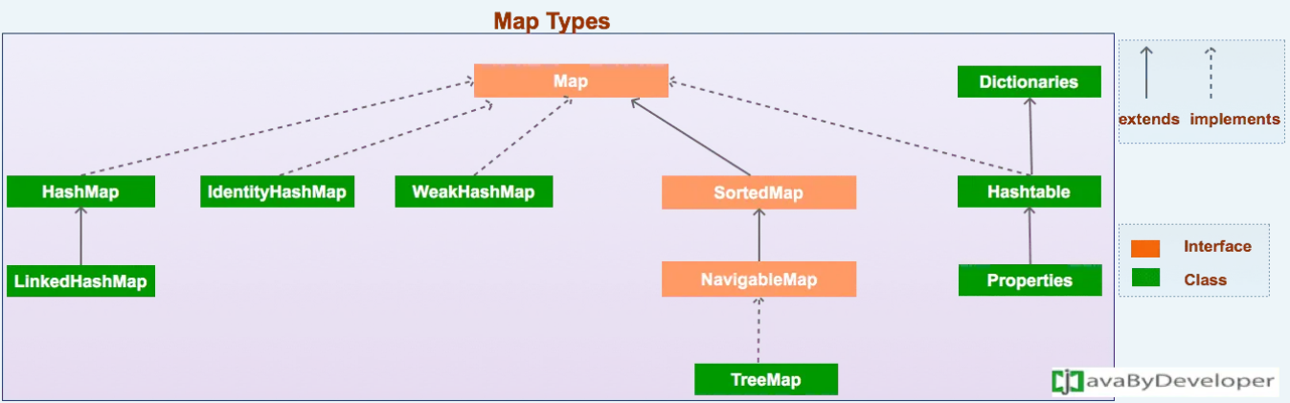

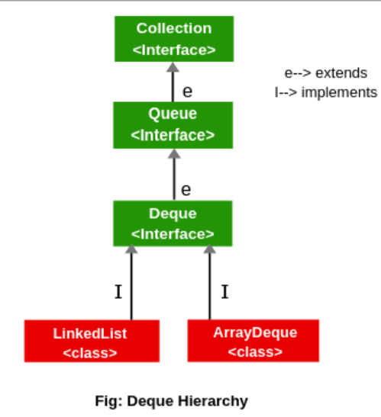

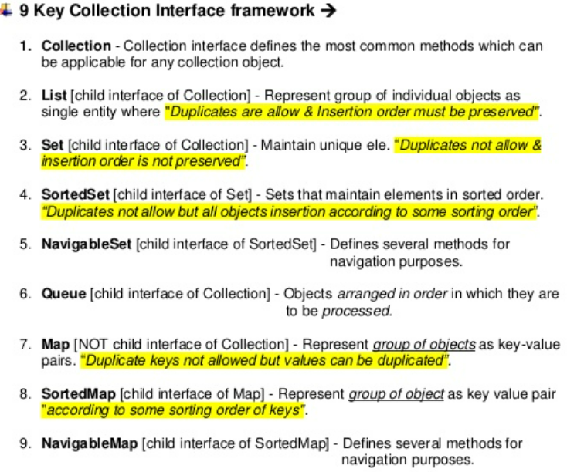



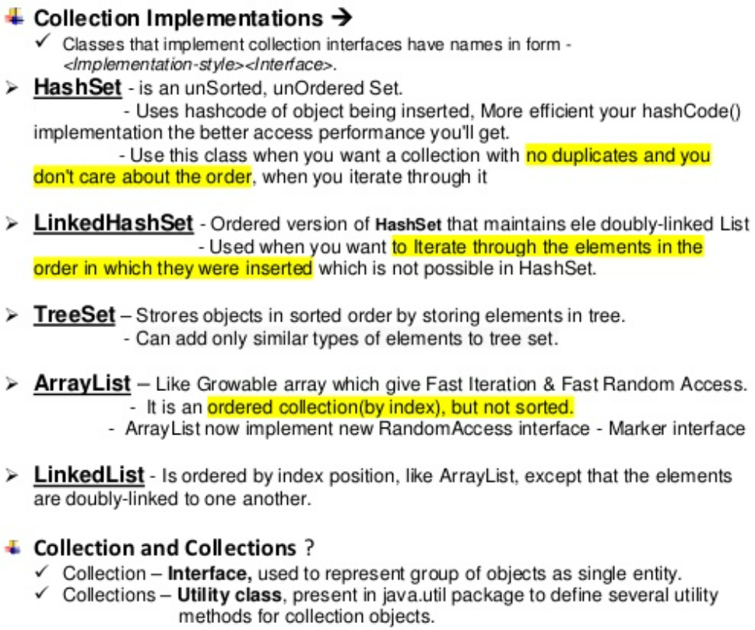

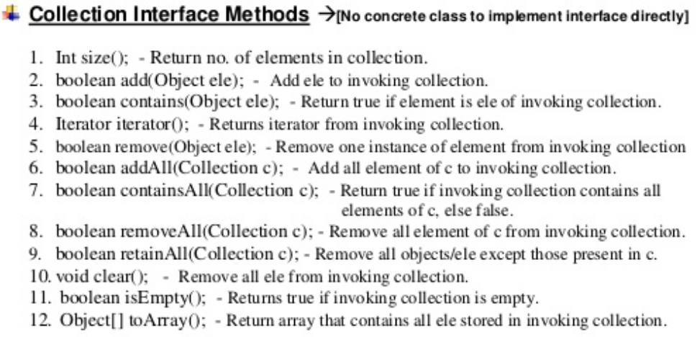

Question – why need to go Collection and Collection Framework?.

Individual variable approach is the first level. There are some problem are there. If we want to represent huge number of values. Declaring Many number of Variable never be a good programing practice. To. over come this problem we should go for Arrays .

In Arrays there are end number of problem like – Fixed in Size, It can hold only Homogeneous data and there is no underlying data structure, that’s why ready made methods support we can not expect. So to overcome this problem we should go for collection.

**Question – Legacy Classes in Collection Interface .**

**Vector,Stack, Hash Table, Properties, Dictionary and Enumation interface these are all came from old generation / version -1.0. these classes known as Legacy class.**

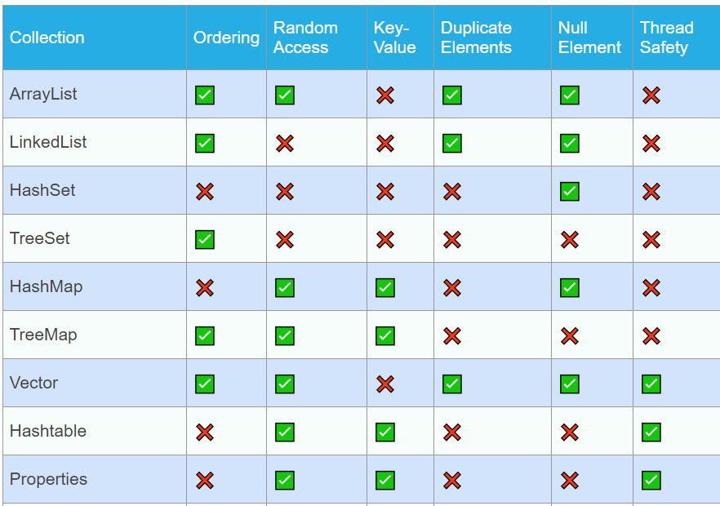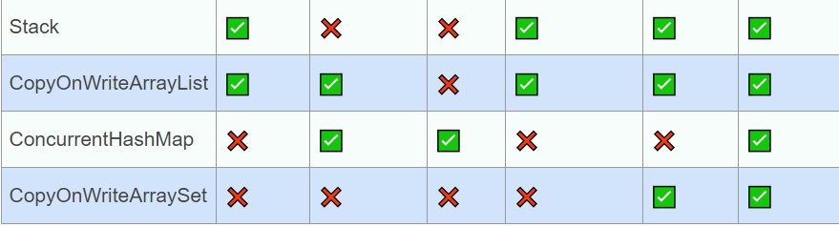

z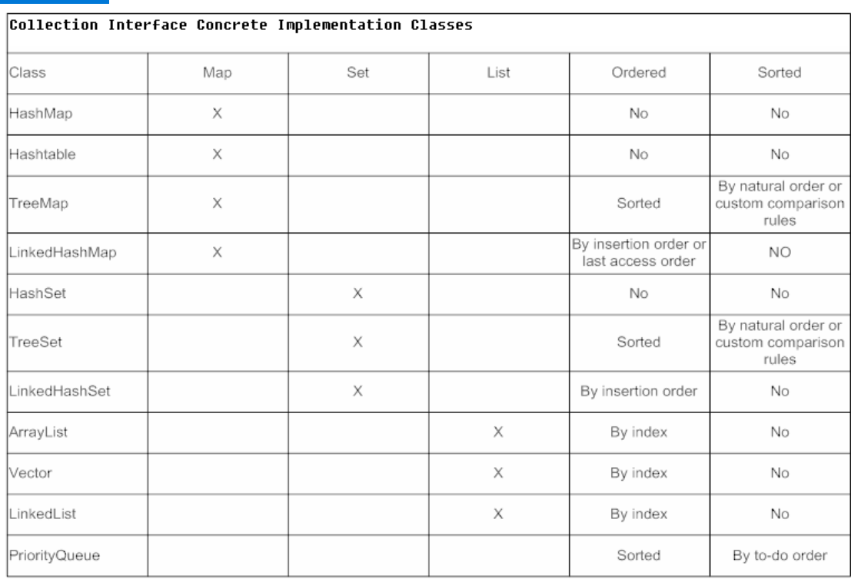

**Question -**

1. **Which of the following classes is Not implemented from the Collection Interfaces?**

**Ans – Hash Table**

1. **Which does not implement the collection Interface?**

**Ans – Map Interface**

1. **Which of the following does Not accept duplicate values?**

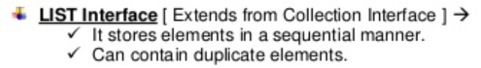Ans- TreeSet – Not Allow duplicate ele.

* **List having index and ordered collection. It is having classes – ArrayList, LinkedList, Vector and Stack.**
* 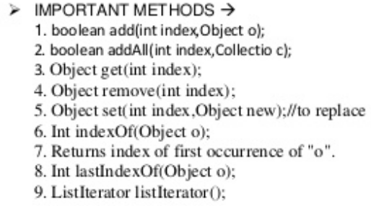**It is the child interface of collection, If we want to represent a group of object as a single entity where Duplicate are allowed and insertion order must be preserved, then we should go for List interface.**
* **Set Interface having /implements– Hashset, LinkedHashSet , tree set.**

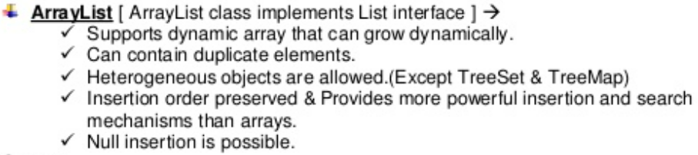

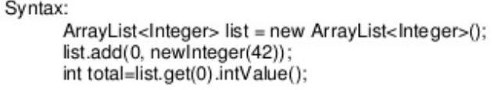

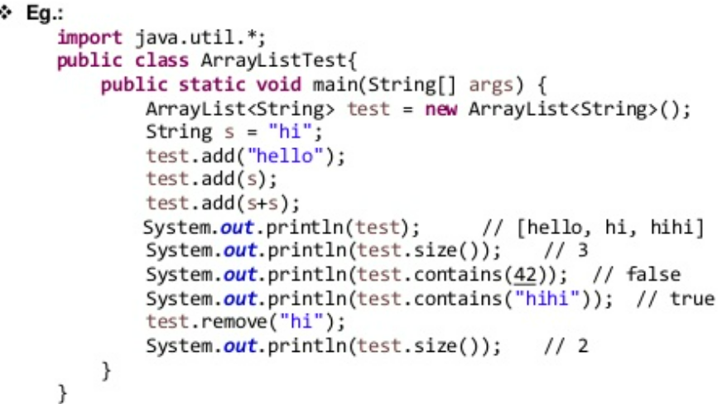

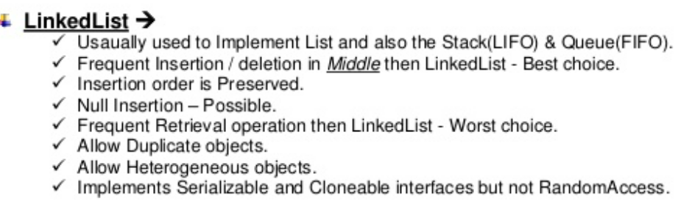

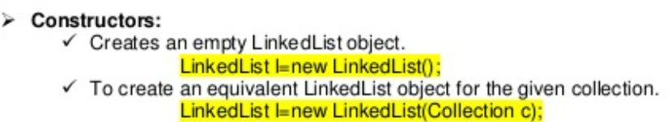

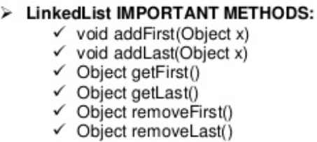

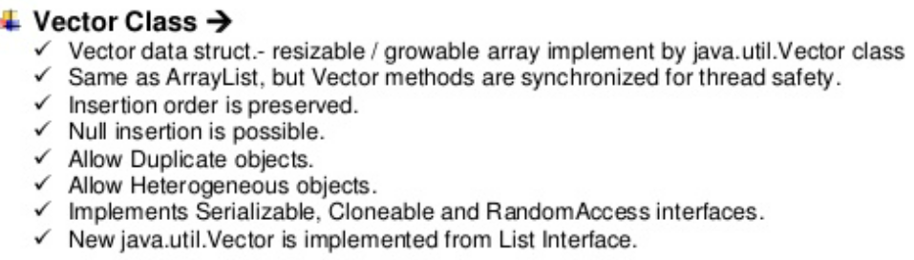





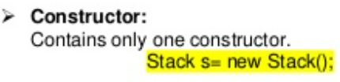

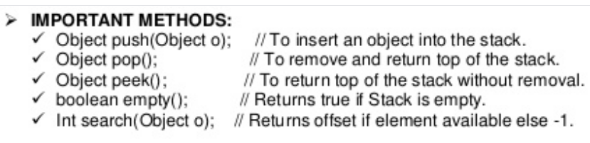



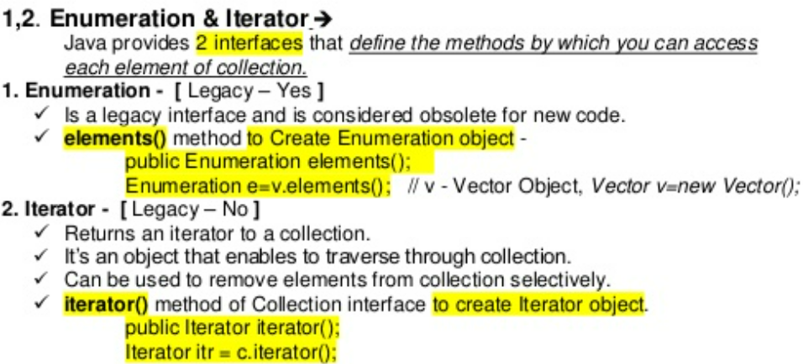

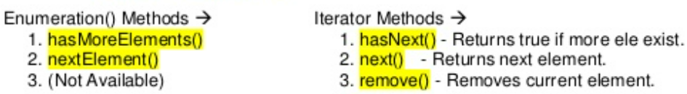

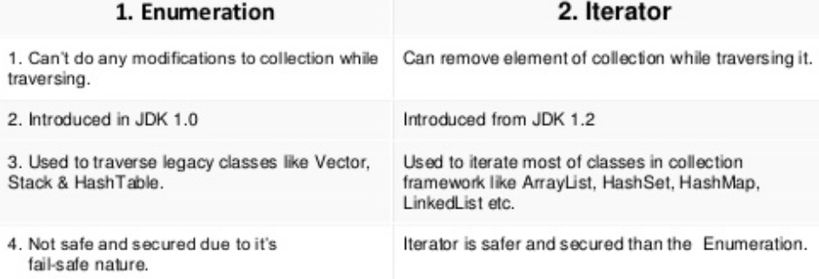

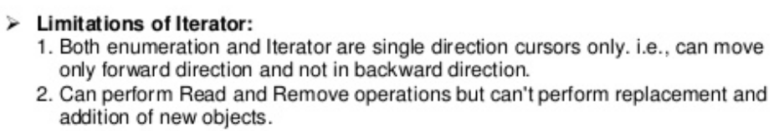



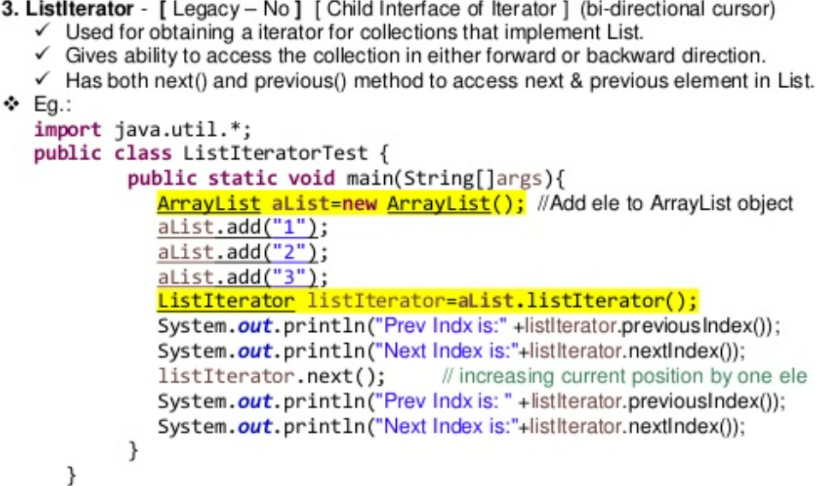

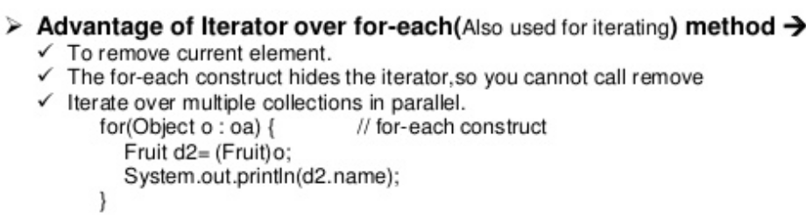

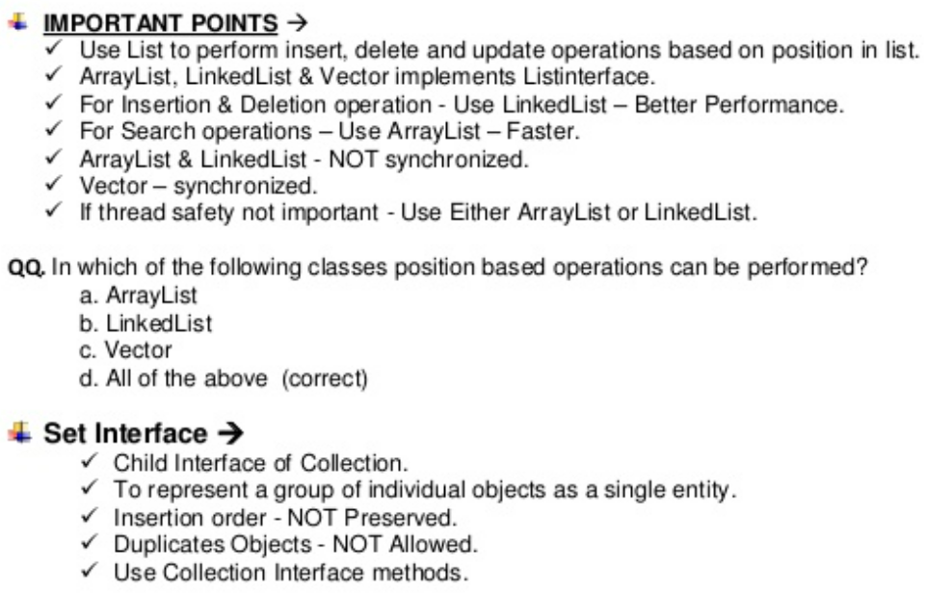

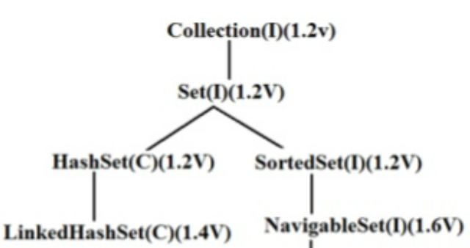

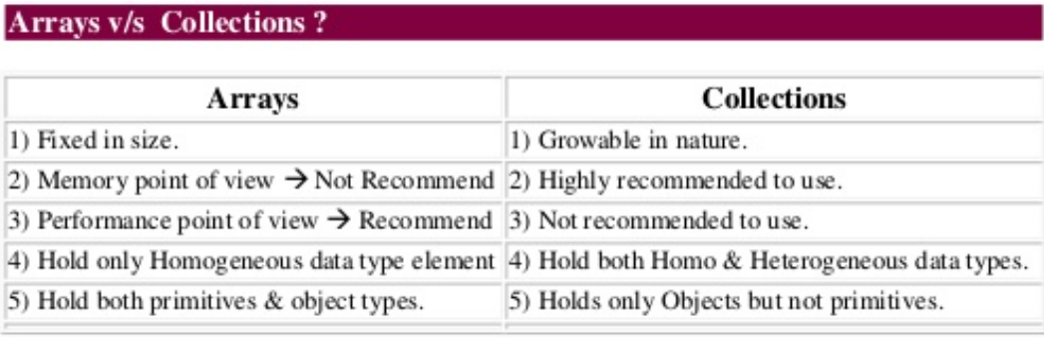

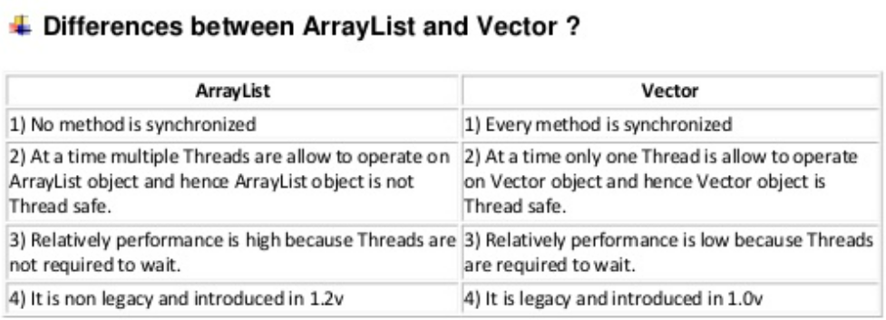

**It is a default**

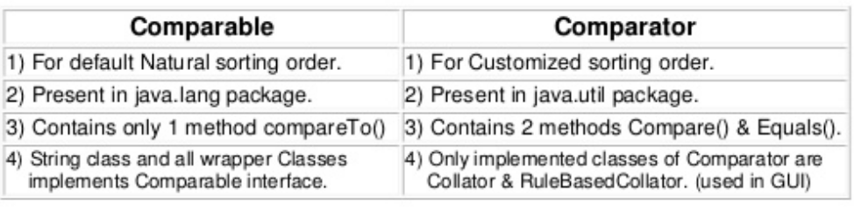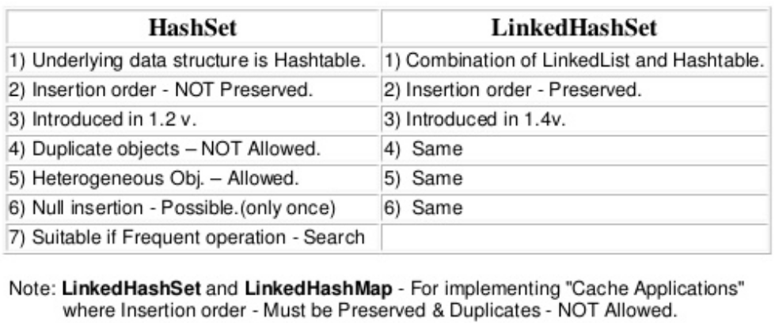

**20) Difference between HashMap and HashTable?**

There are several differences between HashMap and Hashtable in Java:

* Hashtable is synchronized or thread safe, whereas HashMap is not.
* Hashtable does not allow null keys or values. HashMap allows one null key and any number of null values.
* Slower than Hash Map because of thread safe but Hash Map works faster
* The third significant difference between HashMap vs Hashtable is that Iterator in the HashMap is a fail-fast iterator while the enumerator for the Hashtable is not.

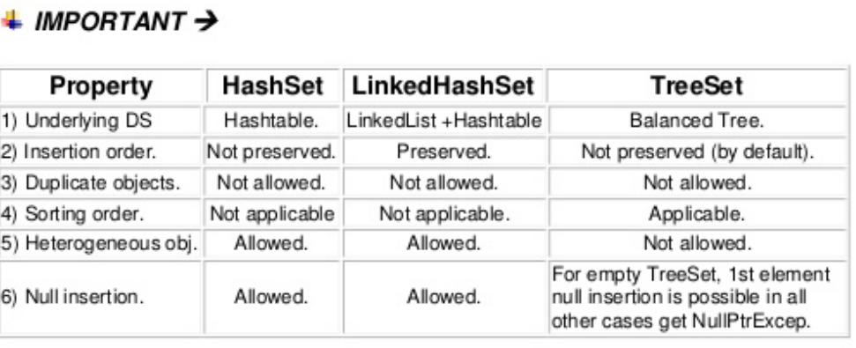

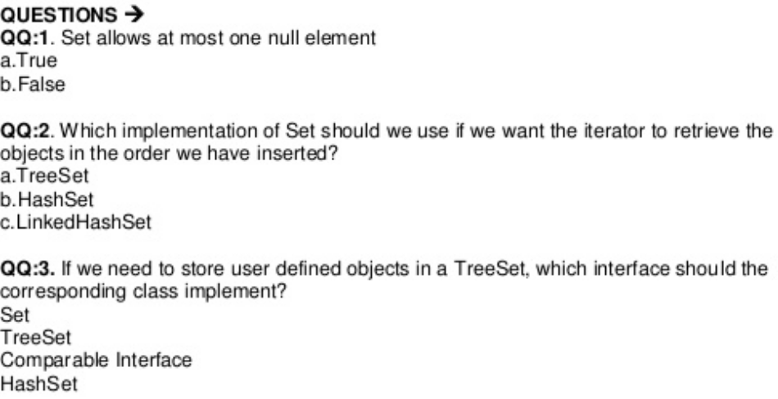

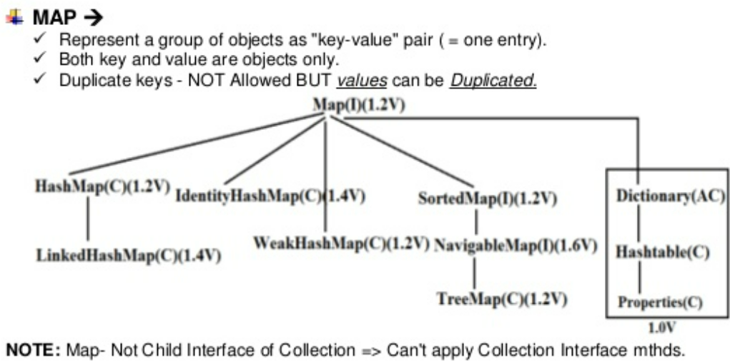

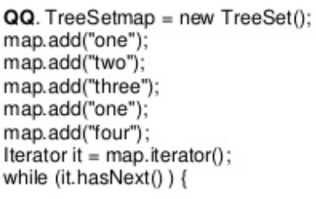

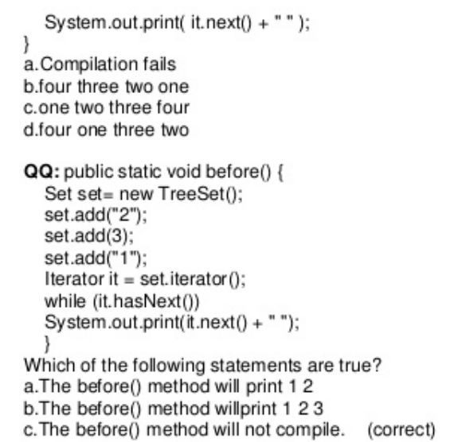

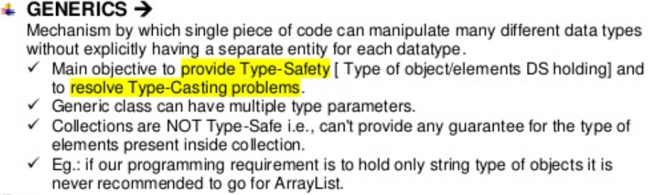

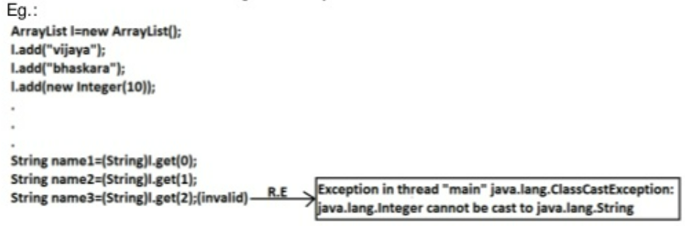

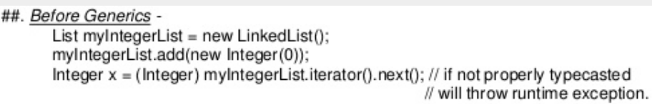

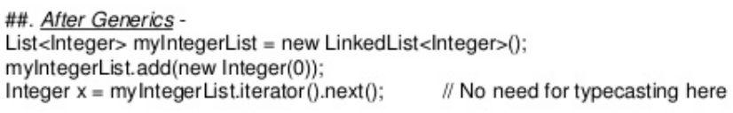

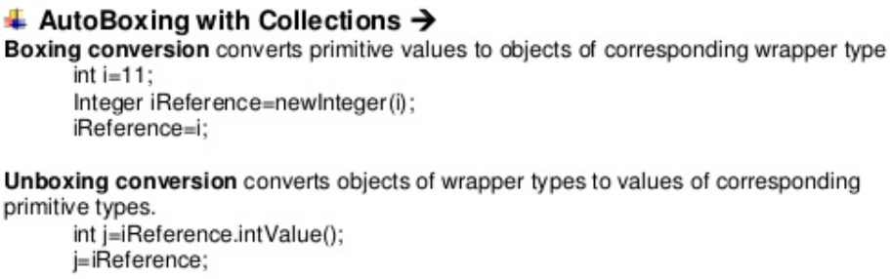

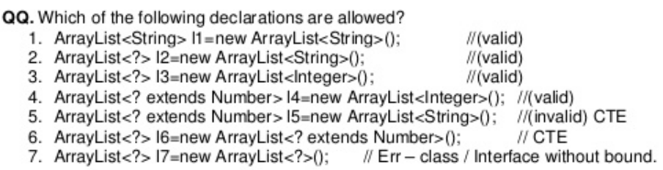

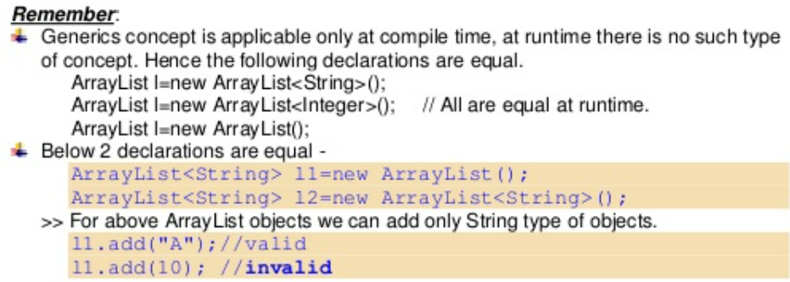

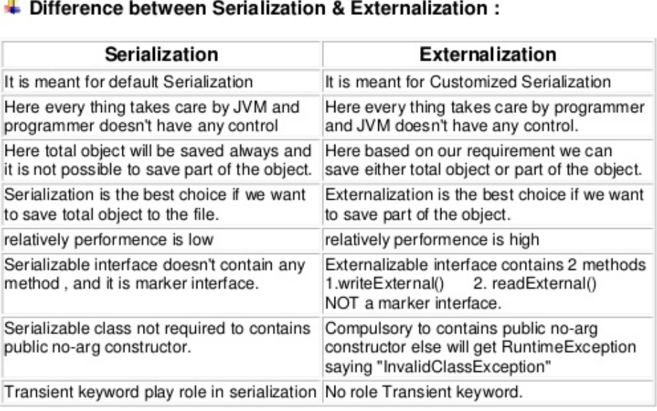

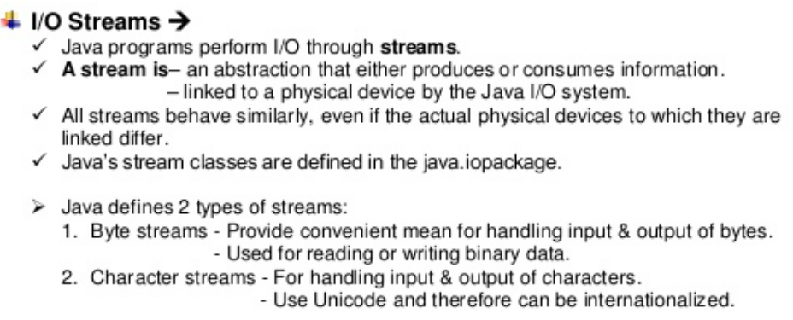

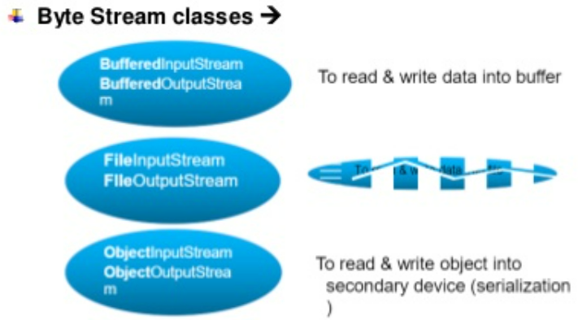

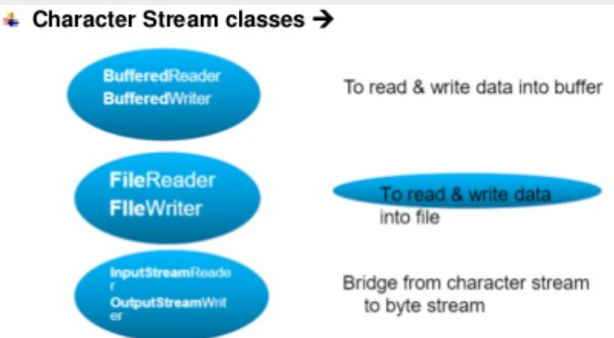

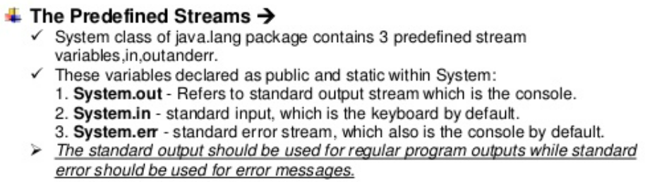

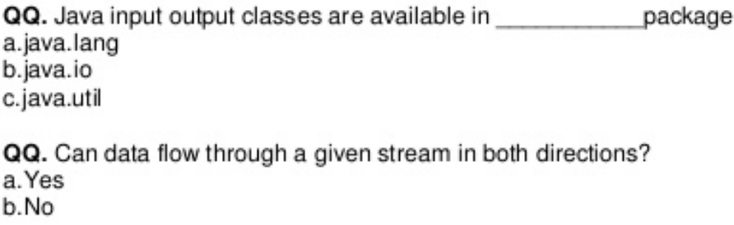

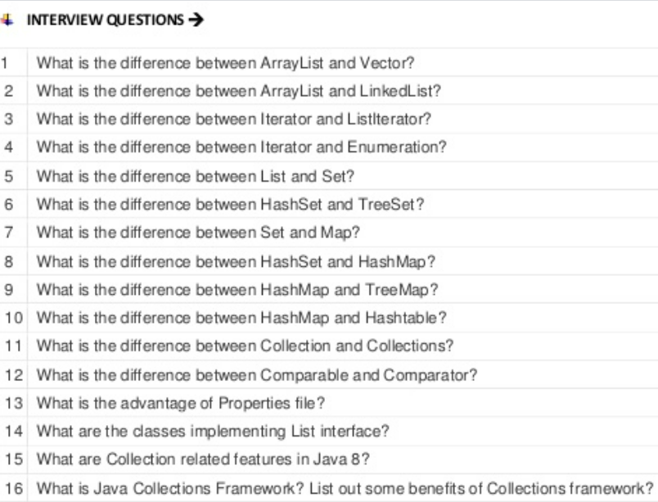

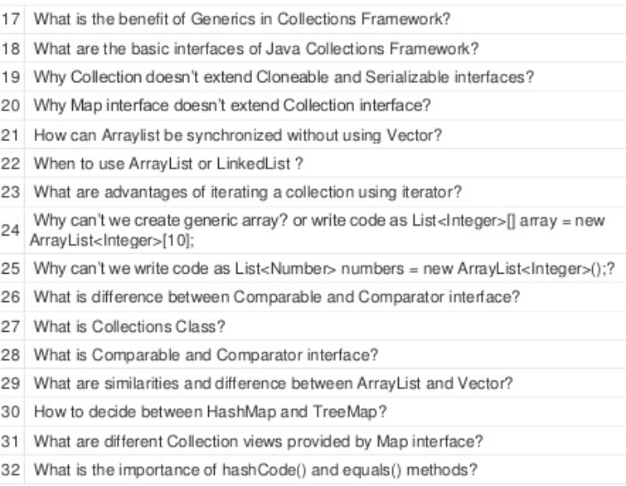

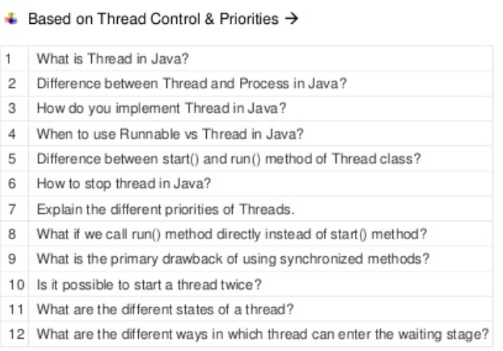

Sketching